OFFICE OF THE MAYOR
26 March 2015
For submission to Council
TABLING OF THE 2015/16 ANNUAL BUDGET

PURPOSE
To present to Council the draft budget for 2015/16 financial year.
BACKGROUND
In terms of section 16(1) of the Local Government Municipal Finance Management Act 56 of 2003, the council of a municipality must for each financial year approve an annual budget for the municipality before the start of that financial year.

(2) In order for the municipality to comply with subsection (1), the mayor of the municipality must
table the annual budget at a council meeting at least 90 days before the start of the budget year.

(3) Subsection (1) does not preclude the appropriation of money for capital expenditure for a
period not exceeding three financial years, provided a separate appropriation is made for each of
those financial years.

FINANCIAL IMPLICATIONS
Implications in line with provision made in the draft budget
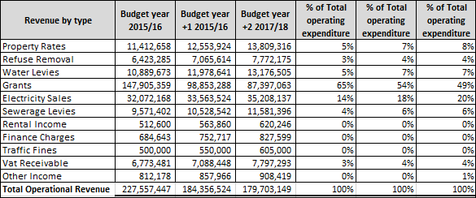
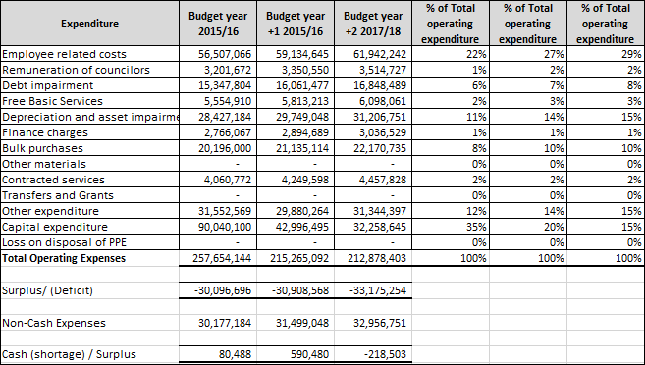

From the above schedule it shows that the Municipality is under severe cash flow constraints.
The Municipality also have outstanding creditors to an amount of R18 million which will put further pressure on the cash flow constraints experienced.
The pressures experienced at the Municipality is mainly caused by the poor collection rate on accounts billed for services that were delivered. This will be addressed in the coming years by implementing strict credit control policies that has been taken into account when the budget was performed. Once a steady cash flow can be maintained from the collections on services delivered, the outstanding creditors can be addressed.
Stricter controls will also be implemented on operational expenditures incurred by the Municipality. These controls will limit the unauthorized, irregular and fruitless & wasteful expenditures to a minimum.

LEGAL IMPLICATIONS
Local Government Municipal Finance Management Act No. 56 of 2003
Treasury Circulars No. 70 & 72

PARTIES CONSULTED
Municipal Manager
Management
Budget Steering Committee
Councilors

RECOMMENDATION
Council is requested to consider the draft budget as per the submission.

Submitted by:

__________________
AM SHASHA
MAYOR

